**Stocksbridge Nursery Infant**

**School**

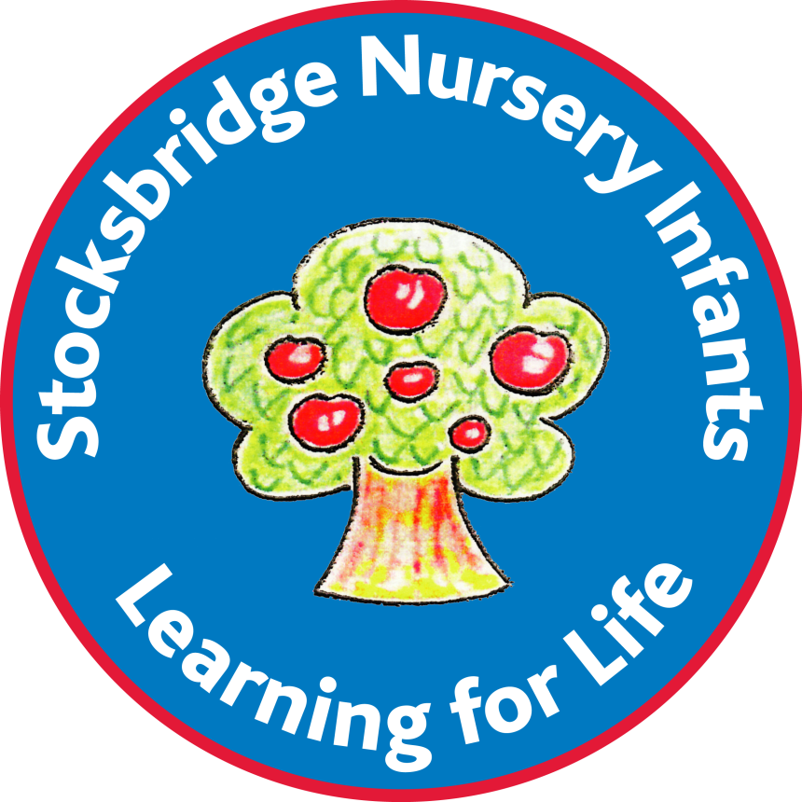

**Personal Development Policy**

Policy adopted: Feb 2024

Policy review date: May 2027

We believe Personal Development is integral in turning this vision into reality. Our carefully planned provision aims to equip pupils with the skills, attributes and experiences needed to flourish academically and personally.

Equality of access and opportunity are embedded throughout our Personal Development curriculum. We celebrate diversity while promoting a sense of belonging. By monitoring involvement and progress, we ensure no child misses out.

This policy outlines our whole-school approach to Personal Development. We see it not as an additional element, but the golden thread running through all aspects of school life. It is the foundation on which academic success is built.

**Our School**

Stocksbridge Nursery Infants is a caring community founded on inclusivity. We live out our values in the day-to-day life of the school through:

* Nurturing relationships between all members
* Providing a safe haven where every child feels secure.
* Extending a warm welcome to all families and visitors
* Maintaining high expectations for mutual respect
* Making learning active, practical and full of wonder
* Putting wellbeing at the heart of every school day

By embedding these values in everything we do, we lay the groundwork for effective Personal Development.

At Stocksbridge Nursery Infants School, we believe that Personal Development is vital for our pupils' growth and future success. We define Personal Development as the process of nurturing well-rounded individuals who are confident, resilient, and equipped with the skills and knowledge needed to thrive in life.

Our Personal Development provision encompasses the academic, social, emotional, physical, moral, and cultural development of each pupil. We aim to provide a holistic education that goes beyond the national curriculum and equips pupils with transferable life skills.

Equality of opportunity is at the heart of our Personal Development offer. We strive to provide enriching experiences that build cultural capital and promote entitlement for all pupils, irrespective of background. Careful monitoring ensures inclusion and equity in our provision over time.

This policy outlines our approach to embedding Personal Development throughout school life. We believe that Personal Development does not just take place in the classroom but is integral to everything we do. By taking a whole-school approach, we can positively shape our pupils' personal growth and readiness for the next stage of their lives.

Personal development through PSHE & the curriculum – overview

|  |  |
| --- | --- |
| Transition | Other |
| Weekly opportunities for parents to tour school with the headteacher prior to starting. | Beat the Street campaign |
| SENCO transition meetings – beginning 6 months prior to transfer. | Sustrans big walk and wheel |
| Home to Nursery transition. | Scooter training |
| In school transition | Modeshift Stars – Active Travel |
| KS1 to KS2 transition. | Be Bright Be Seen Day |
| Extra/bespoke transition for SEND pupils | Sports Day |
| School visits to special and IYA. | Art competitions – |
| Safeguarding and SEND transition for any IYA. | Protected Characteristic – age, gender and relationships (PSHE curriculum/assembly themes) |
| Welcome packs for Nursery, Reception and IYA. | Walk to School week |
| Curriculum | Charity fund raising |
| PSHE lessons | Dr Bike maintenance sessions |
| Zones of Regulation | Balance bike skills |
| Golden Rules and Golden Time | Road safety assembly |
| School values | Fire safety |
| Classroom rules | First aid |
| Assemblies about diversity, equality. | Forest Schools |
| Personal development assemblies | Parent Picnic |
| Weekly praiseboard | Mountain rescue |
| Trips | Enterprise week |
| Trauma informed school approach | Reflected lessons |
| Behaviour policy | Preparation for adulthood as part of SEND reviews. |
| Science lessons (Keeping healthy) | British Values |
| PE lessons | Assemblies about diversity and British Values |
| RE lessons | Covered in the PSHE curriculum |
| Online safety | Sustrans big walk and wheel |
| Online safety as part of SEND reviews |  |
| SEMH | After school clubs |
| Nurture provision | PE clubs |
| Games club | Art club |
| Emotionally Available Adults | Craft club |
| Small group work | Choir |
| School base care plans | Games club |
| 1:1 work | Dance Club |
| Theraplay | Gymnastic Club |

**The delivery of Personal**

**Development**

We interweave Personal Development throughout the curriculum and school life. Key elements are delivered through:

**1. PSHE Curriculum**

Our PSHE curriculum provides the framework for developing self-confidence, relationships, and responsibilities. Pupils explore topics like feelings, friendships, diversity, keeping safe, and being healthy. Lessons give pupils the vocabulary, knowledge and skills for Personal Development.

**2. Physical Development**

PE, physical play, and motor skills sessions develop pupils' physical competence, fitness, and enjoyment of exercise. This supports their overall wellbeing.

**3. Social and Emotional Development**

We nurture social and emotional skills through modelling behaviour, class discussions, cooperative play and learning. Strategies like conflict resolution are explicitly taught to equip pupils for life.

**4. Enrichment Activities**

Clubs, school trips, special events, and theme days provide culturally enriching experiences outside of the classroom. These boost confidence, resilience and cultural capital.

**5. Pastoral Care**

Our pastoral system, including early intervention and nurture support, caters to pupils' individual Personal Development needs. Targeted interventions address social, emotional, or behavioural issues.

**6. Transition Support**

We ease transitions by familiarising pupils with new settings and routines. Additional bespoke support helps pupils with SEND or disadvantage manage change.

**7. Parent Partnerships**

**Impact**

Our Personal Development provision nurtures pupils who:

- Have a strong sense of identity and self-worth

- Can manage emotions, build relationships and communicate effectively

- Make responsible decisions and problem-solve challenges

- Have essential life skills like resilience, empathy and independence

- Value diversity and equality, respecting differences in others

- Are active participants in their community and wider society

- Feel prepared for the next phase of their academic journey

We monitor progress through methods like provision mapping, engagement and well-being assessments, tracking involvement, and gathering parent/teacher feedback. Evaluating impact ensures our Personal Development offer is equitable, enriching and evolving.

**Disadvantaged Pupils and SEND**

We are committed to ensuring equity of access to Personal Development opportunities. For disadvantaged pupils and those with SEND, we:

- Provide financial support for trips, clubs and enrichment

- Make adaptations like using visuals, social stories and sensory tools

- Tailor interventions to target specific social or emotional needs

- Work closely with families to take a consistent approach

- Monitor involvement to quickly address any barriers

Personalised support enables all pupils to benefit from our ambitious Personal Development curriculum.

**Assessment**

- Observations of personal, social and emotional development

- Recording progress through developmental milestones in Communication and Language, and PSED

- Learning journals, Seesaw and progress trackers

**Transitions**

We ease transitions by:

- Sharing & gathering information with new settings about pupils' needs

- Making pre-visits to familiarise pupils with new environments

- Reading stories and doing role play about 'moving on'

- Providing take-home transition books with photos and key info

- Organising joint activities with nursery/Reception classes

- Preparing children for moves between nursery, reception and Year 1

- Using transition objects like a class teddy to build familiarity

- Visits to see new classroom and meet the teacher

These approaches reduce anxiety, promote continuity and develop confidence.

**Working with Families**

We support families to reinforce Personal Development at home by:

- Providing home learning linked to PSHE and enrichment projects

- Regularly communicating about issues like behaviour or friendships

- Signposting to parenting support and family services

- Inviting families to assemblies, performances and celebration events

- Welcoming contributions like sharing cultural traditions

- Signposting parents to support services like parenting classes, family counselling, Early Help

- Organizing events for families to build relationships and engage them in school life

- Seeking input from parents when reviewing policies and initiatives

This fosters a holistic approach between home and school.

**Monitoring and Evaluation**

We reflect on our Personal Development provision by:

- Reviewing curriculum breadth and enrichment uptake

- Analysing wellbeing, behaviour and attendance data

- Observing social and emotional development

- Capturing staff, pupil and parent voice on provision

- Evaluating impact on disadvantaged pupils and those with SEND

This helps refine our offer to nurture confident, happy and resilient learners ready for the future.

**Leadership**

Our Leadership Team will:

- Ensure Personal Development has equal status with academic achievement

- Make sure provision is well-planned, resourced and meets statutory requirements

- Provide high quality CPD to build staff expertise in delivery

- Monitor, review and enhance the Personal Development curriculum and enrichment offer

- Track participation and progress to ensure equity and impact

- Report to governors on the quality of provision and its impact on pupil outcomes

This ensures Personal Development remains a whole-school priority with strong leadership.

-Overseeing curriculum planning and delivery of PD provision

- Leading staff training and development in PD approaches

- Monitoring quality of teaching and standards in PD

- Managing resources and budget for PD

- Coordinating external partnerships and agencies

- Reporting to SLT and governors on PD outcomes

**Staff Training**

We invest in professional development to enhance staff skills and confidence in providing Personal Development opportunities including:

- Specialist PSHE, wellbeing and SEND training

- Guidance on adapting lessons and activities to meet all pupils' needs

- Updates on statutory requirements and evidence-based approaches

- Cascade training to ensure a consistent approach

- Attachment and trauma informed approaches

- Developmental milestones in early years

- Managing behaviour and supporting wellbeing in under 5s

- Specialist early language and communication training

This upskilling enables staff to deliver an impactful Personal Development curriculum.

**Working with External Agencies**

We build partnerships with external experts to complement our Personal Development provision like:

- Healthcare professionals – school nurses, occupational therapists

- Community groups – libraries, local charities and volunteer groups

- Public services – police, fire service

- Specialist support services – counsellors, play therapists

These partnerships further enrich pupils' experiences and support specific Personal Development needs.

**Pupil Voice**

We put pupils at the heart of shaping our Personal Development offer by:

- Regular circle times for pupils to share views and concerns

- Class and school councils to represent pupils' perspectives

- Consulting pupils on initiatives like class charters and school rules

- Encouraging pupil-led campaigns and projects

This empowers pupils to actively contribute to their own Personal Development journey.

**Parent Partnership**

We collaborate with parents/carers by:

- Signposting support services and online safety resources

- Maintaining open communication channels like reading records

- Providing guidance on emotional development and wellbeing

- Encouraging attendance at assemblies, performances and celebration events

- Consulting on policy updates and curriculum enhancements

Working cooperatively with families strengthens consistency between home and school.

**Governor Role**

Our governing board will:

- Approve the Personal Development policy and curriculum

- Monitor the quality and impact of provision through visits and reporting

- Ensure statutory requirements are met and curriculum is well-led

- Support the resourcing and enrichment of the Personal Development offer

- Help connect the school with the wider community

This provides accountability, insight and an additional layer of expertise to enhance our Personal Development provision.