2 x Welfare playworker
Applicant Pack

Contents
The vacancy 3
Post advert 3
Role summary 3
Job description 4
Specific duties and responsibilities 4
Support for the trust/school 4
Changes to these duties 5
Person Specification 6
Job Title: Welfare Playworker 6
Knowledge, experience and skills 6
Qualifications 6
Other skills 6
Interpersonal skills 7
Child protection 7
Stocksbridge Junior School 8
Chorus Education Trust 9
To apply 10

The vacancy

Post advert
Deadline for applications: | 11.59pm on 11th July 2024
Interviews to be held: | Thursday 18th July 2024
To start: | 1st September 2024

We are looking for an enthusiastic Welfare Play Supervisor to join our team! An exciting opportunity is now available for a Welfare Play Supervisor to join our growing team here at Stocksbridge Junior School. Stocksbridge Junior School is an outstanding school and has been for almost twenty years. Situated to the north-west of Sheffield, this inclusive school is an integral part of the community it serves, ensuring the families and children of Stockbridge and surrounding areas receive the very best quality of education and support.

Required to start as soon as possible, the successful candidate will be responsible for supervising the children during lunchtime on the playground, organising play equipment, encouraging children into active play, ensuring they show respect, and that they have a safe and happy lunchtime. Applicants should enjoy working with children, have a positive and caring attitude, be reliable, flexible and committed to supportive teamwork. Applicants need to be reliable and dedicated and have good communication skills in order to liaise with children and other staff members. They should be willing to join in games, oversee quiet activities and supervise play.

The hours of work will be 11.50am-1.05pm, Monday to Friday.

Role summary
Post title: |  | Welfare Playworker
Profile: |  | Support Staff
Grade: |  | 1
Grade spinal point range: |  | SCP2
Salary: |  | £22366 (pro rata £3614.78)
Accountable SLT post: |  | Samantha Gaymond, Headteacher
Line manager (if different): |  | Tracey Birley, Business Manager
Staff to be supervised or line managed by post holder: |  | No
Post holder will work with: |  | Children and Staff
Holiday and sickness relief: |  | No
Purpose of post: |  | To provide supervision and interact and play alongside pupils during lunch and breaktimes.
Version revised: |  | 1
Contract: | Permanent |  | 6.25 hours per week/38 weeks per year
Job description
The post holder must at all times carry out his/her responsibilities within the spirit of the school and trust policies and within the framework of legislation relating to academies and education, with particular regard to the statutory responsibilities of the trust and the governing body of the school.
The specific duties and responsibilities include but are not limited to:

Specific duties and responsibilities
- To supervise the children during their outdoor / indoor play experience during lunchtime.
- To supervise children in transition from outside / inside during inclement weather.
- To lead instigate playground activities / games.
- To ensure the standards of behaviour are maintained and comply with the school behaviour policy.
- To assist in dealing with problems from unruly behaviour and report such matters to the Headteacher, Deputy Head, Learning Mentor and Senior Management Team.
- To ensure the children have a calm, orderly and enjoyable lunchtime to enable them to have full access to the learning in the afternoon.
- To carry out other duties relating to lunchtime supervision as requested by the Headteacher, Deputy Head. Learning Mentor and Senior Management Team.
- To ensure school security regulations are upheld.
- To change clothes, clean and care for personal cleanliness of the children as appropriate.
- That basic first aid is administered as appropriate and records are kept in accordance with school procedure.
- To work alongside school staff prior to lunchtime within the classrooms to establish purposeful working relationships with individuals or small groups of children.
- To work as part of a team and will always be under the direction of the Headteacher, Deputy Head and Senior Management Team.

Support for the trust/school
- Be aware of and comply with policies and procedures relating to child protection, health, safety and security, confidentiality and data protection, reporting all concerns to an appropriate person.
- Work in a flexible way to respond to the needs of the trust and to fulfil other duties and responsibilities appropriate to the grade and role as and when required.
- Be aware of and support difference and ensure equal opportunities for all.
- Appreciate and support the role of other professionals.
- Attend and participate in relevant meetings as required.
- Contribute to the overall ethos/work/aims of the trust/schools.
- Participate in relevant training, other learning activities and performance management as required.
- Team responsibilities: all staff are considered part of the overall trust team and may be required to provide assistance to colleagues in other areas from time to time commensurate with the role, skillset and grade.
- From time to time, to meet the needs of the trust, you may be asked but not expected to work hours additional to your normal working hours. The trust will give you as much notice as possible and you will be paid/recompensed for such work. Situations where this might be required are, for example: relevant key school events such as open evenings, exam results days, trips, clubs, training etc.

Changes to these duties
The above duties are not exhaustive and the post holder may be required to undertake tasks, roles and responsibilities as may be reasonably assigned to them by the Headteacher/Principal.
The job description and allocation of particular responsibilities will be kept under review and may be amended via consultation with individuals, the governing body or board of trustees and/or senior leadership team as required. Trade union representation will be welcomed in any such discussions.

Person Specification

Job Title: Welfare Playworker
REQUIREMENTS | Essential | Desirablee | Assessment method  A = application  I = interview  R = reference

Knowledge, experience and skills
Generic administrative experience to include word processing/typing, filing, collating, proof-reading of material, data entry and spreadsheet use, using Microsoft Office packages. |  |  | A
Customer services experience. |  |  | A
Working in a busy environment with many priorities and conflicting deadlines. |  |  | A / I
Experience of an education, training or similar environment. |  |  | A
Organisation and bookings for events. |  |  | A / I

Qualifications
Good level of literacy and numeracy eg GCSE Maths and English or substantial relevant experience. |  |  | A
Evidence of regular, relevant and recent personal development. |  |  | A

Other skills
Communicate effectively with people at all levels eg school staff, students, governors and external contacts/ suppliers. |  |  | I
Work effectively as part of a team recognising own role as a team member. |  |  | A / I
Able to maintain a positive focus, accepting constructive criticism positively and learning from it. |  |  | A / I
Demonstrate an enthusiastic and positive approach regarding change, having a definite ‘can do’ mentality. |  |  | I
Ability to learn from experiences. |  |  | I
Ability to carry out instructions accurately and effectively as directed by line manager. |  |  | I
Demonstrate customer care. |  |  | A
Ability to work alongside young people (not necessarily in school environment). |  |  | A / I

Interpersonal skills
Ability to maintain confidentiality |  |  | A
Accuracy when receiving information (verbally and written) and communicate information effectively and accurately. |  |  | I
Able to make a positive contribution to the team. |  |  | A
Able to reflect on performance and further develop own knowledge and skills to improve performance. |  |  | I
Maintains standards set by the organisation. |  |  | I
Takes responsibility for own actions. |  |  | I
Ability to work alone unsupervised and manage own workload. |  |  | A / I

Child protection
A commitment to the responsibility of safeguarding and promoting the welfare of young people. |  |  | I

Stocksbridge Junior School
Stocksbridge Junior School strives for its children to have no limits to their ambitions and to aspire to reach their full potential. We prepare children for life-long learning, valuing the uniqueness of every child and providing for their needs within a safe, happy and caring environment in which everyone is equal and all achievements are celebrated.
Everyone at Stocksbridge Junior School aims to combine high standards with a broad and rich curriculum where education is the fusion of excellence and enjoyment. The curriculum is adapted to suit the needs of our pupils to ensure they are all ‘learning together’.
The school, situated to the north-west of Sheffield, welcomes 270 pupils through its doors, from Year 3 to Year 6.

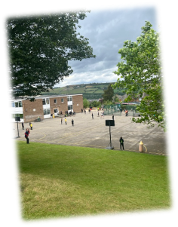

In addition to trust-wide benefits for all staff, those at Stocksbridge Junior School also have access to:
- Supportive and friendly staff and leadership team.
- Well equipped and comfortable staffroom.
You can view the school website at: www.stocksbridge-jun.sheffield.sch.uk.

Chorus Education Trust
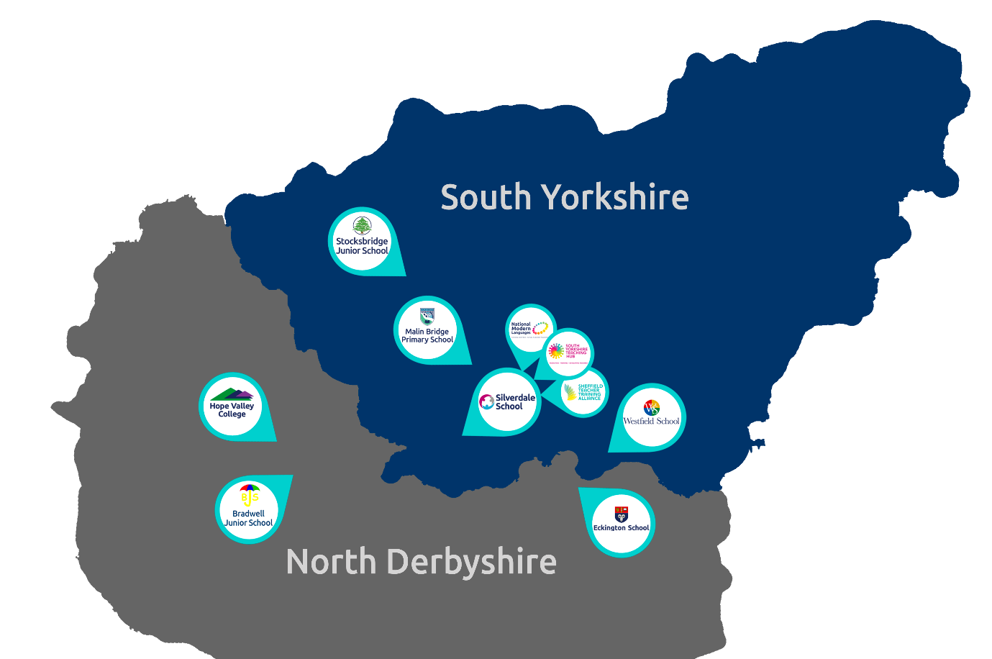
Chorus Trust is a growing trust, committed to providing every child with the best education in both primary and secondary schools across South Yorkshire and Derbyshire. We train and develop teachers, giving our children access to the very best educational thinking and practice.
Our vision is ‘Outstanding Achievement for All’. We want to create a culture of success in which our children and young people can succeed. We do this through the provision of safe and supportive schools, collaborating to ensure our children benefit from a more effective spend of public money.
As part of the Chorus Trust Team, all staff have access to:
 | An ethos of being a force for good; of being part of a team that enables ‘outstanding achievement for all’. |  | Leading edge training and development through the South Yorkshire Teaching Hub.
 | A collaborative environment encouraging knowledge sharing and support. |  | Access to discounted health schemes through Westfield Health and Westfield Rewards Schemes.
 | Competitive pension schemes: Teacher’s Pension Scheme (teaching staff) and local government pension scheme (support staff). |  | Term-time only contract postholders have the freedom of having school holidays off.
 | Career progression opportunities within a growing, local trust. |  | Support for flexible working arrangements.

You can read more about Chorus Trust at www.chorustrust.org.

To apply
- Full application pack and application forms available from: www.chorustrust.org/vacancies
- Completed application forms are to be sent to: Tracey Birley, Business Manager
at: t.birley@stocksbridge-jun.sheffield.sch.uk
- Please note that CVs and council application forms will not be accepted.
- Deadline for applications: 11.59pm on Thursday 11th July 2024
- Interviews to be held: Thursday 18th July 2024
At Chorus Trust we are committed to the safeguarding of all our pupils, please visit our website to access our safeguarding and child protection policy at www.chorustrust.org/policies.
The trust will conduct an online search of the successful candidate in line with the DfE’s keeping children safe in education advice.
The successful candidate will be required to complete a Disclosure and Barring Service (DBS) check in line with the Rehabilitation of Offenders Act (ROA) 1974 (Exceptions) Order 1975 and the Police Act Regulations.

