
Stocksbridge NI School
Long Term Plan Cycle B 2023-2024
 | Summer 1 |  |  | Summer 2
Theme | Extreme Environments |  |  | Seasides
Sensational Start  Fabulous Finish | Explorer visiting- James Ketchell |  |  | A visit to the seaside- Bridlington
SMSC and values
Online safety   | YEAR 1  Online Safety  https://projectevolve.co.uk/toolkit/resources/strand/privacy-and-security/early-years-7/  - Year 1: Add Online Relationships - discuss communicating kindly online https://projectevolve.co.uk/toolkit/resources/strand/online-relationships/early-years-7/  YEAR 2  Relationships  Online safety  https://projectevolve.co.uk/toolkit/resources/strand/privacy-and-security/early-years-7/  - Year 2: Add Online Relationships - discuss differences between online and offline friendships  https://projectevolve.co.uk/toolkit/resources/strand/online-relationships/early-years-7/ |  |  | YEAR 1  Online safety  https://projectevolve.co.uk/toolkit/resources/strand/privacy-and-security/early-years-7/  - Year 1: Add Self Image and Identity - link body image to reputable online sources  https://projectevolve.co.uk/toolkit/resources/strand/self-image-and-identity/early-years-7/  YEAR 2  Online Safety https://projectevolve.co.uk/toolkit/resources/strand/privacy-and-security/early-years-7/  -Year 2: Add Privacy and Security - introduce idea of protecting private information online  https://projectevolve.co.uk/toolkit/resources/strand/self-image-and-identity/early-years-7/
Being a Mathematician   | Y1  Number: Multiplication & Division (Including multiples of 2,5,& 10)  Number: Fractions  Geometry: Position & Direction |  |  | Y1  Number: Place Value (within 100)  Measurement: Money  Measurement: Time
 | Y2  Number: Fractions  Measurement: Time |  |  | Y2  Statistics  Geometry: Position & Direction  Problem solving & efficient strategies
Being a Writer and a Reader   | Narrative  Y1  Use patterns and language from familiar stories in own writing; write complete stories with a simple structure: beginning – middle – end, decide where it is set and use ideas from reading for some incidents and events.  Y2  Imitate familiar stories by borrowing and adapting structures; write complete stories with a sustained, logical sequence of events; use past tense and 3rd person consistently; include setting; create characters, e.g. by adapting ideas about typical story characters; include some dialogue; use phrases drawn from story language to add interest, (e.g.) she couldn’t believe her eyes. |  |  | Persuasion  Y1  Read captions, pictures, posters and adverts that are trying to persuade. Begin to recognise what they are trying to do and some of the ways they do it.  Through games and role play begin to explore what it means to persuade or be persuaded, and what different methods might be effective.  Y2  As part of a wide range of reading, explore simple persuasive texts (posters, adverts, etc.) and begin to understand what they are doing and how.  Evaluate simple persuasive devices (e.g.) Say which posters in a shop or TV adverts would make them want to buy something, and why)  Create simple signs posters and adverts (involving words and/or other modes of communication) to persuade others to do, think or buy something.  Continue to explore persuading and being persuaded in a variety of real life situations through role-play and drama.  Poetry  Y1 Seaside acrostic poems  Y2 Sand by Meish Goldish  The Sea Poem by James Reeves
 | Year 1 | Year 2 |  | Year 1 |  | Year 2
Grammar | Writing in past tense Coordination using ‘so’.  Suffixes er, est | Expanded noun phrases subordinating (when, if)/coordinating (and, so, but)  Adverbs-  suffix ly, ful |  | Capital letters for proper nouns.  Prefix un |  | Expanded noun phrases subordinating (when, if)/coordinating (and, so, but)  Speech marks Prefixes - ment, ness & less.  Sentence form – commands  Apostrophes for the possessive.
Handwriting | Numerals and capital letters. | Order to teach joins.  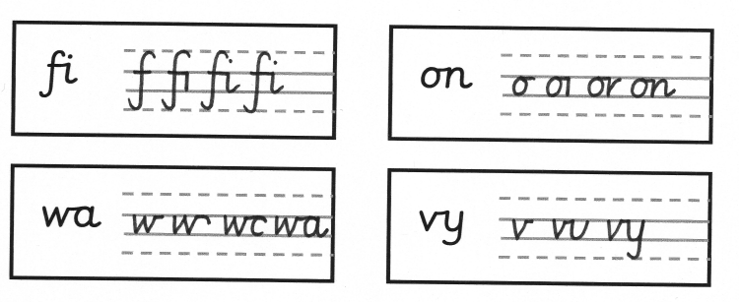  Use the joins within words. |  | Capital letters.  Revision of errors.  (Expectation that all upper and lower case letters & numerals are formed correctly by the end of Y1) |  | Order to teach joins.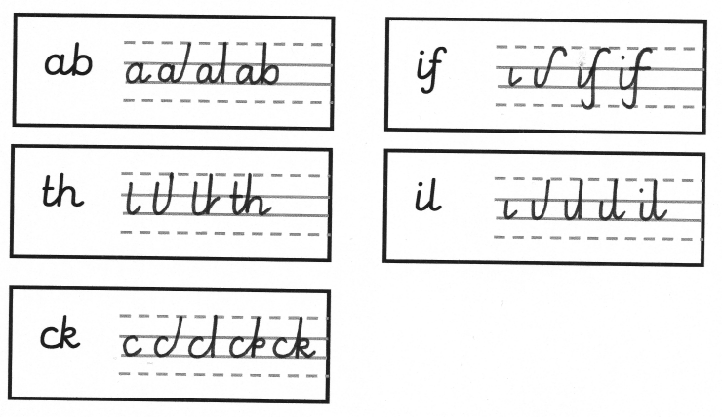  Use the joins within words.
Spellings | In line with monsterphonics HFW spellings  Recap of 100 words that were taught in Autumn | In line with monsterphonics  Recap of CEW and spelling rules |  | In line with monsterphonics HFW spellings  Recap of 100 words that were taught in Autumn |  | In line with monsterphonics  Recap of CEW and spelling rules
Being a Scientist   | Animals including humans  find out about and describe the basic needs of animals, including humans, for survival (water, food and air)  Living things and their habitats  identify that most living things live in habitats to which they are suited and describe how different habitats provide for the basic needs of different kinds of animals and plants, and how they depend on each other  Aim: to learn about extreme environments and how animals and people have adapted. |  |  | Use of everyday materials (Year 2)  Pupils should be taught to:  identify and compare the suitability of a variety of everyday materials, including wood, metal, plastic, glass, brick, rock, paper and cardboard for particular uses  Everyday materials (Year 1)  Pupils should be taught to:  -describe the simple physical properties of a variety of everyday materials  - compare and group together a variety of everyday materials on the basis of their simple physical properties.  Aim: Investigate, which material makes the best lenses for sunglasses and why  Seasonal changes- local environment throughout the year to explore and answer questions about plants growing in a habitat
Being a Historian   | Not this half term |  |  | Pupils should be taught about:  - changes within living memory.  - the lives of significant individuals in the past who have contributed to national and international achievements- Grace Darling  Aim: To know how seaside visits have changed over time.  To know the part that Grace Darling played in the rescue of survivors from a wrecked merchant ship in 1838
Being a Geographer   | Locational knowledge  name and locate the world’s seven continents and five oceans  Human and physical geography  Identify seasonal and daily weather patterns in the United Kingdom and the location of hot and cold areas of the world in relation to the Equator and the North and South Poles.  Geographical skills and fieldwork  use aerial photographs and plan perspectives to recognise landmarks and basic human and physical features  Aim: To know human and physical features of hot and cold areas of the world, naming and identifying them on a map. |  |  | Human and physical geography  Use basic geographical vocabulary to refer to physical and human features- beach, cliff, coast, sea, ocean, harbour, port, shop, lighthouse  Use fieldwork to observe, measure and record the human and physical features in Bridlington using a range of methods, including sketch maps. Compare to Stocksbridge features that we looked at in a previous topic.  Ongoing: use simple compass directions (North, South, East and West). Name the 4 countries of the United Kingdom.  Aim: To use fieldwork skills to talk about the physical and human features of a coastal town (Bridlington) and use these to devise a map with a key.
Being a Computer User   | Year 1  SSoW KS1 Unit 4A - Simple Programs: Bee-Bot  In this series of lessons, pupils will learn how to use floor robots, e.g. BeeBots in a more structured way. They will learn about algorithms and programs, and create their own simple and extended programs, and use logical thinking to plan out algorithms to solve given problems.  Year 2  SSoW Unit 4.2 Extending Bee-Bot Programs  In this series of lessons pupils will extend their knowledge of programming floor robots, e.g. Bee-Bots and create more complex programs to draw numbers and create a robot dance. They will learn more about algorithms and programs, and use logical thinking to plan out algorithms to solve given problems. |  |  | Year 1  TCC Y1 – Programming animations.  Learners will be introduced to on-screen programming through ScratchJr. Learners will explore the way a project looks by investigating sprites and backgrounds. They will use programming blocks to use, modify, and create programs. Learners will also be introduced to the early stages of program design through the introduction of algorithms.  Year 2  TCC Y1 – Programming animations.  Learners will be introduced to on-screen programming through ScratchJr. Learners will explore the way a project looks by investigating sprites and backgrounds. They will use programming blocks to use, modify, and create programs. Learners will also be introduced to the early stages of program design through the introduction of algorithms.
Being a Designer   | Textiles  Design  generate, develop, model and communicate their ideas through talking, drawing, templates, mock-ups and, where appropriate, information and communication technology  Make  Select from and use a wide range of materials and components, including textiles  Evaluate  Evaluate their ideas and products against design criteria  Aim: To develop weaving skills using fabric and a loom |  |  | Not this half term
Being a Musician   | Musical Activities – learn a wide range of songs and perform them.  To use ‘higher’ or ‘lower’ to describe sounds  To pitch-match simple phrases  To explore vocal timbre  To use graphic notation to represent pitch  To play ascending and descending melodies on tuned percussion  To sing pentatonic songs. To begin to recognize pentatonic scales. |  |  | Musical Activities – learn a wide range of songs and perform them.  To compose simple pentatonic melodies  To play and sing melodies that move up and down by step  To recognise melodies that move by step or leap  To use graphic notation to represent a melody  To prepare songs for performance  To perform simple instrumental accompaniments
Being an Artist   | Pupils should be taught:  To develop a wide range of art and design techniques in using colour, pattern, texture, line, shape, form and space.  To produce creative work, exploring their ideas and recording  Aim- to create a mixed media collage. |  |  | Pupils should be taught to  To know about great artists, craft makers and designers, and understand the historical and cultural development of their art forms, whilst making links to their own work.  To develop a wide range of art and design techniques in using colour, pattern, texture, line, shape, form and space.  To produce creative work, exploring their ideas and recording their experiences.  Aim- to create a landscape picture of the seaside.
Being a Sportsperson   | Indoor PE  YEAR 1  GetSet4PE:  Target Games  In this unit, pupils develop their understanding of the principles of defending and attacking for target games. Pupils use both underarm and overarm actions and are given opportunities to select and apply the appropriate action for the target considering the size and distance of the challenge.  YEAR 2  GetSet4PE:  Target Games  In this unit, pupils develop their understanding of the principles of defending and attacking for target games. They develop the skills of throwing, rolling and striking towards a target and are given opportunities to select and apply the appropriate action for the target considering the size and distance of the challenge. |  | Outdoor PE  YEAR 1  GetSet4PE:  Athletics  In this unit pupils will develop skills required in athletic activities such as running at different speeds, changing direction, jumping and throwing. In all athletic based activities, pupils will engage in performing skills and measuring performance, competing to improve on their own score and against others.  YEAR 2  GetSet4PE:  Athletics  In this unit pupils will develop skills required in athletic activities such as running at different speeds, jumping and throwing. In all athletic based activities, pupils will engage in performing skills and measuring performance, competing to improve on their own score and against others. They are given opportunities to work collaboratively as well as independently. They learn how to improve by identifying areas of strength as well as areas to develop. | Indoor PE  YEAR 1  GetSet4PE:  Team Building  In this unit pupils develop their teamwork skills. They work individually, in pairs and in small groups, learning to take turns, work collaboratively and lead each other. They develop key skills of communication and problem solving, They are given the opportunity to discuss and plan their ideas and reflect on their success.  YEAR 2  GetSet4PE:  Team Building  In this unit pupils develop their teamwork skills. They develop key skills of communication and problem solving. They learn to discuss, plan and reflect on ideas and strategies. They lead a partner whilst considering safety. Pupils have the opportunity to show honesty and fair play. The also begin to use basic map skills. | Outdoor PE  YEAR 1  GetSet4PE:  Net and Wall Games  In this unit, pupils develop their understanding of attacking and defending principles in net games such as using a ready position to defend their court and placement of a ball into space. They use and develop skills such as throwing, catching, tracking and hitting a ball.  YEAR 2  GetSet4PE:  Net and Wall Games  In this unit, pupils develop their understanding of attacking and defending principles in net games such as using a ready position to defend their court and placement of a ball into space. They use and develop skills such as throwing, catching, tracking and hitting a ball. They learn how to score points in these types of games and how to play to the rules.
Studying Religions   | https://www.natre.org.uk/member-login/  Y1  1.10 What does it mean to belong to a faith community? (C,J,M)  Y2  1.4 What is the ‘good news’ Christians believe Jesus brings? |  |  | https://www.natre.org.uk/member-login/  Y1  1.9 How should we care for the world and for others, and why does it matter? (C,J,NR)  Y2  1.8 What makes some places sacred to believers? (C,M)

